apt-**get** update -y

apt-**get** upgrade -y

apt-**get** install build-essential gcc make apache2 libapache2-mod-php7.0 php7.0 php7.0-cli php7.0-common apache2-utils unzip wget sendmail inotify-tools -y

wget https://github.com/ossec/ossec-hids/archive/2.9.0.tar.gz

tar -xvzf 2.9.0.tar.gz

cd ossec-hids-2.9.0

sh install.sh



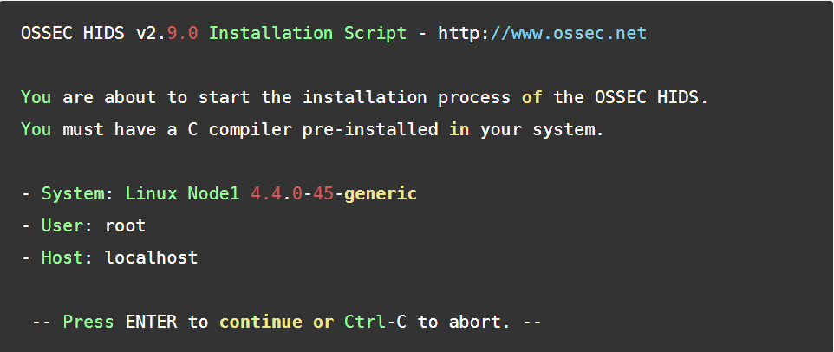

- What kind **of** installation **do** you want (server, agent, **local**, hybrid **or** help)? **local**













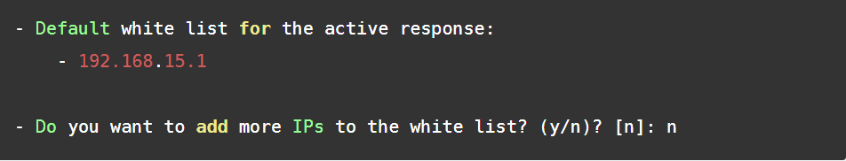

3.5- Do you want to enable remote syslog (port 514 udp)? (y/n) [y]:

- Remote syslog enabled.



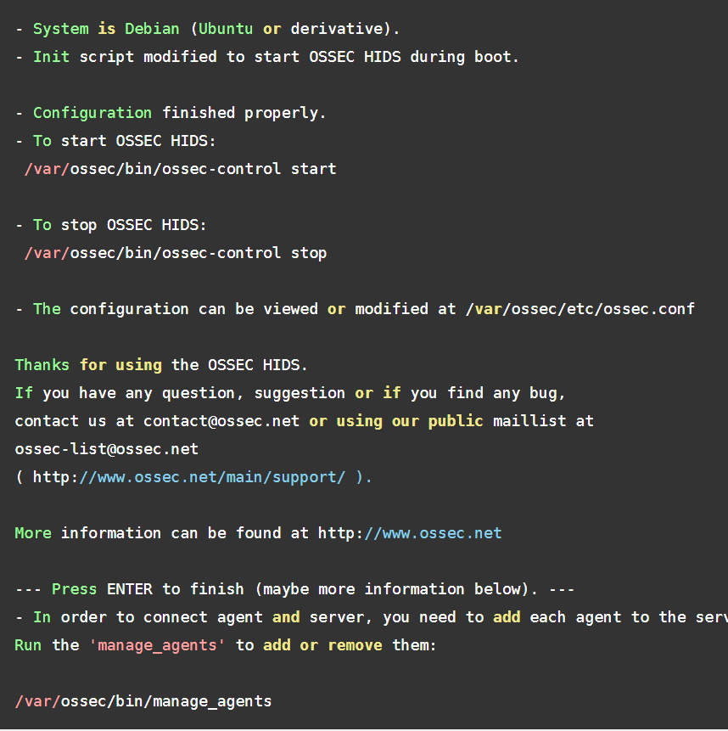

/var/ossec/bin/ossec-control start

vi /**var**/ossec/etc/ossec.conf

vi /**var**/ossec/rules/local_rules.xml

/var/ossec/bin/ossec-control restart

wget https://github.com/ossec/ossec-wui/archive/master.zip

unzip master.zip

mv ossec-wui-master /**var**/www/html/ossec

cd /**var**/www/html/ossec

systemctl restart apache2

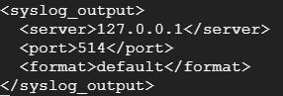

**#** /var/ossec/bin/ossec-control enable client-syslog

**#** /var/ossec/bin/ossec-control start